Topic: Email Basics
When I am done this lesson, I will know:
- What email is
- How to set up an email account
- Some basic email features
- How to send a basic email

Pre and Post Self-Assessment
 | Pre | Pre | Post | Post
 | Yes, I know this | No, I want to learn this | Yes, I know this | I still need more practice to learn this
I know what email is
I know how to set up an email account
I understand some basic email features
I know how to send a basic email

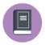
New Words and Terms

email
inbox
outbox
junk mail/spam
deleted/trash
compose
draft
reply
forward
email folders/labels
contact
carbon copy
What is Email?
Email is electronic mail that was developed to provide a way to send and receive messages more quickly than standard mail.
An email address has three components:
Component | Example
Email ID | john.smith
The @ symbol | @
The domain name of the email server | gmail.com

In the above example the email address would be john.smith@gmail.com
There are many different email services. Some common ones are:
- www.hotmail.com
- www.gmail.com
www.yahoo.ca

Although there are many different email services, they have common features like:
- Inbox
- Outbox/Sent box
- Junk mail/Spam
- Deleted/Trash
- Drafts
Compose/Create new email
Note: We are going to use Gmail to learn how to use email. If you already have a Gmail email, you can skip over the Setting up a Gmail Account section.
Gmail is a free email service through Google.
Setting up a Gmail Email Account
Go to www.gmail.com  Click the “Create an account” button. | 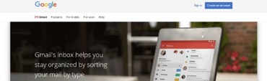
Fill in the information required.  Remember to use a strong password. | 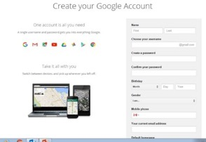
You will be asked to put in a phone number.  This will be used to verify your account. If you don’t have a cell phone number, check with your instructor to see if you can use the number where you are learning.  Follow the steps as they appear. | 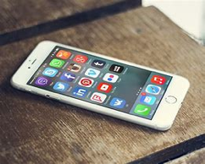
Record your new email address and password somewhere safe. | 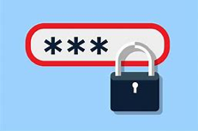
Using Your Email Account
When you log in to a gmail account, you will be taken to your INBOX.
The INBOX is the folder where unread and read emails are stored that you have not deleted.
Emails that have not been read will usually stand out somehow. They might be bold or be a different colour.
Email Folders
The most common folders are:
- SENT
- SPAM/JUNK
- TRASH
DRAFTS
SENT: After you have sent an email it will automatically be stored in the SENT folder.
SPAM/JUNK: Emails such as advertisements that your email account has blocked or filtered are stored here.
TRASH: Emails that you have deleted are stored here.
DRAFTS: Emails that you have started or are working on are stored here.
Email – Create a LABEL
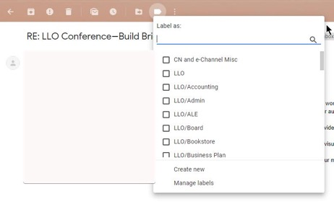
You can create your own FOLDERS to organize emails you want to keep. In Gmail, they are called LABELS. You will see a folder at the top of the page. If you click on it you will see this drop-down. This allows you to create a new label.
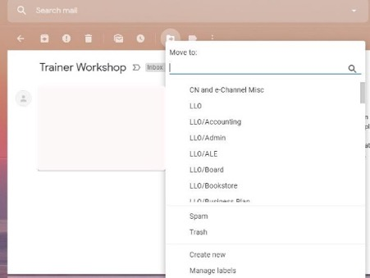
When you want to add an email to a label, you open the email from your INBOX. Click on the icon at the top that looks like a folder with an arrow on it. You will see this drop-down. From here you can move the email into the folder or label you want.
Email – Replying
When you open an email and read it, you have the option to:
- Reply
- Reply All
- Forward
- Delete
REPLY: Send a message back to the person who sent you the current email.
REPLY ALL: If the email was sent to yourself AND others, when you reply to all, everyone who received the original email, will also receive your reply.
FORWARD: The forwarding feature can be used to send an email someone else sent you to a different person.
DELETE: This will move the email to the deleted folder. You can still see the email in the folder. If you delete an email by accident, you can move it back to the inbox.

DISCUSSION QUESTION
When would you forward email?

Contacts/Address Book
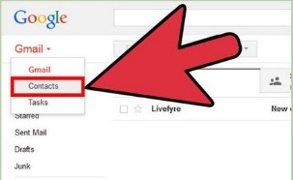
Most email accounts will let you save other people’s email addresses in a Contacts Folder or Address Book.
Within your address book or contacts folder there should be a link called NEW or ADD or ADD NEW CONTACT. You can click on this to add a new email address.
Creating and Sending Email
To create a new email you will need to click on a link labeled NEW or COMPOSE or CREATE.
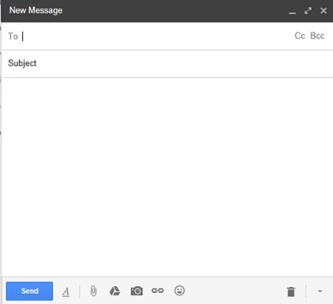
You will now have a blank email on your screen.

TO: This is where you will need to type the person’s email address.
- Some email accounts will allow you to start typing the address or person’s name and the remainder pops up for you
- For others you will need to use your CONTACTS folder or ADDRESS BOOK to find the address
You can enter more than one person’s name

CC: CARBON COPY
- Used when you want a copy of your email sent to another recipient as well
Used in the workplace frequently
BCC: BLANK CARBON COPY
- A copy of an email message sent to a recipient whose email address does not appear in the message
The person in the TO box will not know that the person in the BCC box is also getting the email
SUBJECT: Gives the recipient an idea of what your email is about
- Only needs to be a few words
Example: Kitchen Helper Position
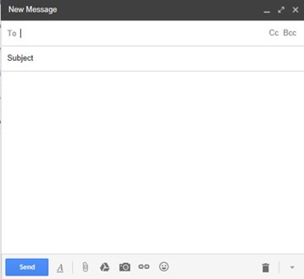
BODY: This is where you type your email message.
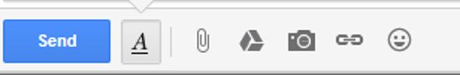
You can use features similar to ones in Microsoft Word, such as bold, underline, font size, etc. by clicking on the A at the bottom of the New Message box.

Once you have written your email, and you are happy with it, you can click send.

Attaching a File to an Email
- To attach a file, you first need to create or reply to a message
- Most email accounts have a paper clip icon to indicate the link used to attach a file
- Common labels are: ATTACH or INSERT
- Click on that link
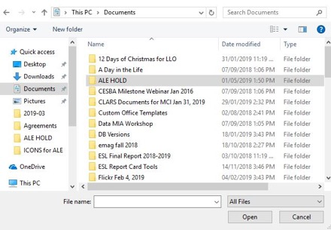
A box should pop up that will allow you to search for a file you would like to attach.
Search for and select the file you wish to attach (left click once to select).
Click OPEN.
The file should now be attached to your email. When you are ready and have double checked everything, click SEND.
Email Safety Myths and Truths
Myth | Truth
The email says it is from someone I know. So it must be from someone I know. | An email sender can add any from address they want. Spammers use “from” addresses that are forged. They use things that are familiar to you to try and trick you.
If I open an email but don’t click any links in the email, I will be safe. | By opening a suspicious email an attacker can tell your account is active. If you are not 100% an email is safe, you shouldn’t open it.


Try this/Practice
Send an email to your instructor.
 | Watch these videos to learn more about Gmail basics  Source: GCFGlobal.org | https://www.youtube.com/playlist?list=PL007352170EA6EB06

Optional: I Want to Learn More
Complete a full Gmail tutorial here.  Source: GCFGlobal.org | https://edu.gcfglobal.org/en/gmail/

Complete a full general tutorial here.  Source: GCFGlobal.org | https://edu.gcfglobal.org/en/email101/


Ontario Adult Literacy Curriculum Framework Connection
Competency | Task Group(s)
Find and Use Information | Read Continuous Text  Interpret Documents  Extract Information from Films, Broadcasts and Presentations
Communicate Ideas and Information | Interact with Others  Complete and Create Documents

